ToxGenie Multi-Group Comparison Report

Report Date: 2026-06-24 15:55:25

Study Title: | Reproduction Test

Analysis Method: | Dunnett's Multiple Comparison Test (via Log transformation) for Avg Dry Weight

Study No.: | Test-135 | Test Material: | Test Chemicals
Exposure Time: | 24-hours | Test Medium: | Elendt M4

Table 1. Raw Data Summary for Avg Dry Weight
(Unit: mg/L)

Dose | 1 | 2 | 3 | 4
Control | 1.2900 | 1.3200 | 1.5900 | 1.2700
6.25 | 1.2700 | 1.0000 | 1.0800 | 0.9700
12.5 | 1.3200 | 1.3700 | 1.3500 | 1.3400
25 | 1.2900 | 1.3300 | 1.2000 | 1.1700
50 | 0.7800 | 0.7000 | 0.6600 | 0.7700

Step 1. Outlier Detection (Data QA/QC) Analysis

Table 2. Identified Statistical Outliers

Dose | Replicate No. | Observed Value | Normal Range (1.5 IQR)
Control | 3 | 1.5900 | [1.1313, 1.5413]

Note: Outliers were identified using Tukey's fences (Values outside Q1 - 1.5*IQR or Q3 + 1.5*IQR).
These values are flagged for Quality Assurance purposes but are typically retained to reflect true biological variance, unless experimental error is proven.

Step 2. Descriptive Statistics

Table 3. Descriptive Statistics for Avg Dry Weight
(Unit: mg/L)

Dose | N | Mean | SD | SE | CV (%) | Median
Control | 4 | 1.36750 | 0.14975 | 0.07487 | 10.95062 | 1.30500
6.25 | 4 | 1.08000 | 0.13491 | 0.06745 | 12.49142 | 1.04000
12.5 | 4 | 1.34500 | 0.02082 | 0.01041 | 1.54771 | 1.34500
25 | 4 | 1.24750 | 0.07500 | 0.03750 | 6.01202 | 1.24500
50 | 4 | 0.72750 | 0.05737 | 0.02869 | 7.88633 | 0.73500

Abbreviations & Explanations:
- N: Number of replicates, Mean: Average response value.
- SD: Standard Deviation, SE: Standard Error, CV (%): Coefficient of Variation.

Table 4. Shapiro-Wilk's test for normality on the Avg Dry Weight

Dose | Statistic | P-value | Result
Control | 0.7519 | 0.0403 | Reject Normal Distribution
6.25 | 0.8823 | 0.3486 | Normal Distribution
12.5 | 0.9984 | 0.9951 | Normal Distribution
25 | 0.9249 | 0.5649 | Normal Distribution
50 | 0.8970 | 0.4162 | Normal Distribution

P>0.05 indicates Normal Distribution.
Final decision: The Avg Dry Weight data does not follow a normal distribution.

Table 5. Levene's test for homogeneity on the Avg Dry Weight

Statistic | P-value | Result
0.78026 | 0.55523 | Equal Variances

P>0.05 indicates Equal Variances.
Final decision: The Avg Dry Weight data shows equal variances.

Table 6. Transformed Data Summary for Avg Dry Weight (Log transformation)

Dose | 1 | 2 | 3 | 4 | Mean | SD
Control | 0.2546 | 0.2776 | 0.4637 | 0.2390 | 0.2058 | 0.1788
6.25 | 0.2390 | 0.0000 | 0.0770 | -0.0305 | 0.3530 | 0.7314
12.5 | 0.2776 | 0.3148 | 0.3001 | 0.2927 | 0.6185 | 0.9419
25 | 0.2546 | 0.2852 | 0.1823 | 0.1570 | 0.6830 | 1.2463
50 | -0.2485 | -0.3567 | -0.4155 | -0.2614 | 0.4383 | 1.7077

Note: Data were transformed using the log method prior to statistical analysis.

Table 7. Shapiro-Wilk's test for normality on the transformed Avg Dry Weight.

Dose | Statistic | P-value | Result
Control | 0.76414 | 0.05192 | Normal Distribution
6.25 | 0.89921 | 0.42713 | Normal Distribution
12.5 | 0.99836 | 0.99492 | Normal Distribution
25 | 0.92503 | 0.56550 | Normal Distribution
50 | 0.89749 | 0.41870 | Normal Distribution

P>0.05 indicates Normal Distribution.
Final decision: The data follows a normal distribution.

Table 8. Levene's test for homogeneity on the transformed Avg Dry Weight.

Statistic | P-value | Result
1.01300 | 0.43181 | Equal Variances

P>0.05 indicates Equal Variances.
Final decision: The data shows equal variances.

Statistical Analysis Procedure & Decision Tree

The statistical analysis for 'Avg Dry Weight' was conducted based on the following decision steps:

1. Assumption Verification (Normality & Homogeneity):
- Since the raw data did not meet the assumption(s) of Normality, data transformation was attempted to stabilize variance and normalize the distribution.

2. Data Transformation Strategy:
- A Log transformation was selected and applied.
- Logarithmic transformation reduces skewness in positive data and stabilizes variance when it increases with the mean. It was chosen because it yielded the highest combined score for Normality and Homogeneity among all candidates.
- The transformed data successfully met the required statistical assumptions (Normality and Homogeneity of Variance). Thus, Parametric Tests were performed on the transformed data.

3. Final Selected Test Method:
- Because after applying data transformation, the transformed data successfully met the required statistical assumptions (Normality and Homogeneity of Variance), the Dunnett Test (Parametric) was selected as the post-hoc test.
- Prior to this post-hoc analysis, an Omnibus Test (One-Way ANOVA) was performed to confirm if any statistically significant differences exist among the dose groups (p < 0.05).
- The selected method is appropriate for comparing multiple treatment groups against a single control group to determine the NOEC/LOEC (No Observed Effect Concentration/Lowest Observed Effect Concentration) or NOAEL/LOAEL (No Observed Adverse Effect Level/Lowest Observed Adverse Effect Level).

Table 9. One-Way ANOVA on the transformed Avg Dry Weight data.

F-statistic | P-value | Result
38.2808 | 0.0000 | Significant differences among doses
P<0.05 indicates a statistically significant difference among groups.

Table 10. Post Hoc Analytical Method: Dunnett's Test on the transformed Avg Dry Weight data.

Control | Dose | P-value | Result
Control | 6.25 | 0.0043 | Significant difference from Control
Control | 12.5 | 0.9985 | No significant difference from Control
Control | 25 | 0.4043 | No significant difference from Control
Control | 50 | 0.0000 | Significant difference from Control
P<0.05 indicates a statistically significant difference from the Control.

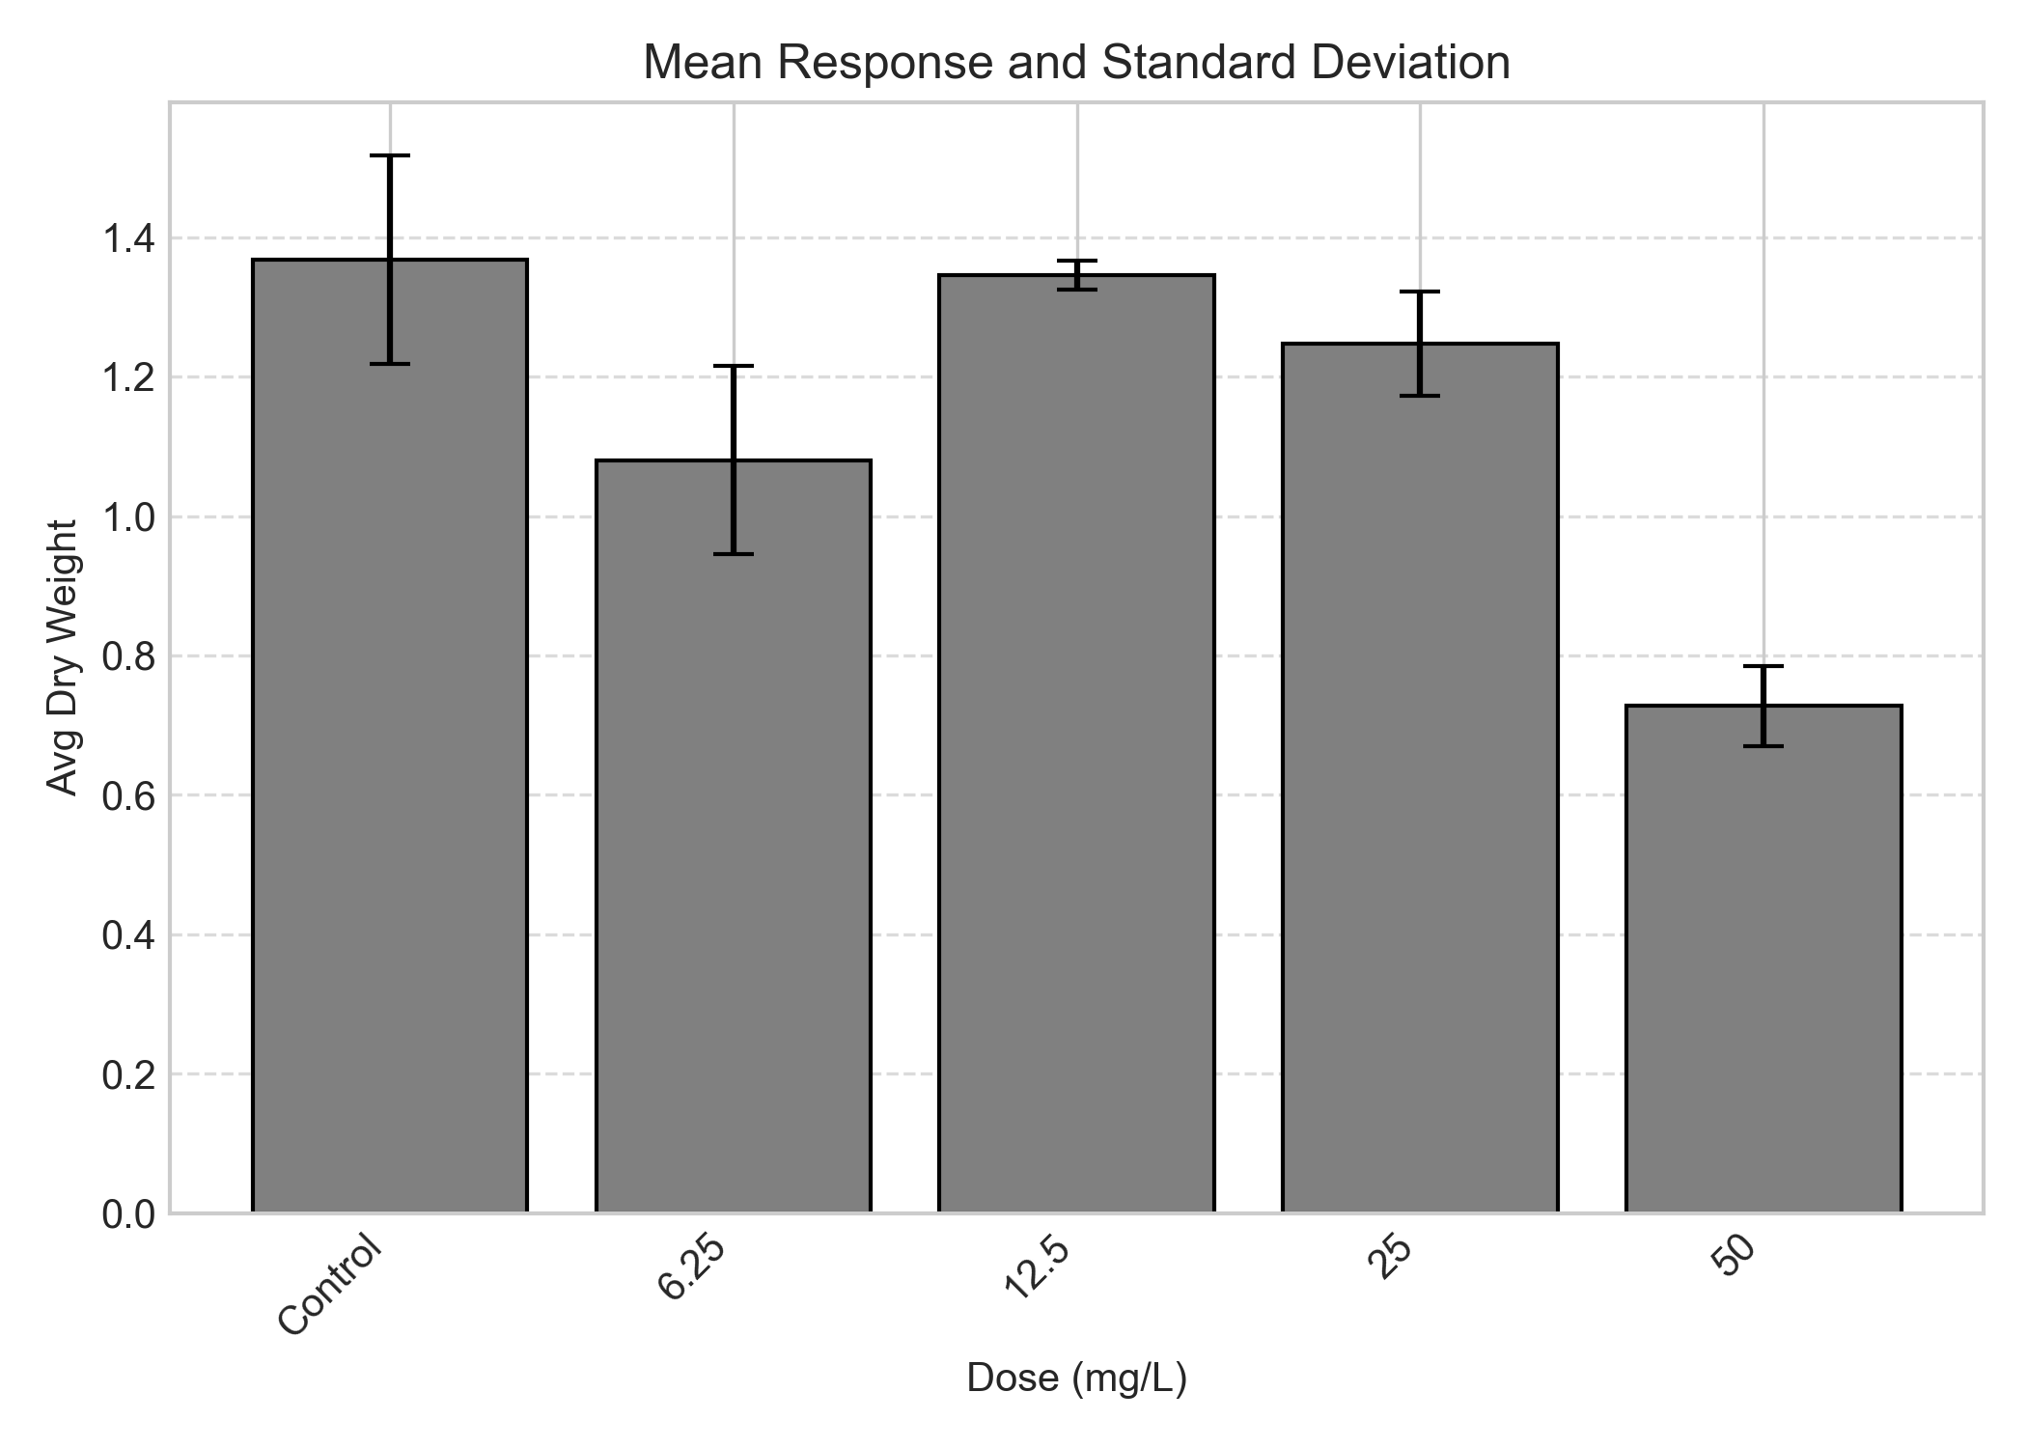
Figure 1. Dose-response trend for Avg Dry Weight. Bars represent the mean and Standard Deviation (SD).

 | Analyst: | ToxGenie

