ToxGenie Hypothesis Test Report

Report Date: 2026-06-24 15:47:46

Study Title: | Zebrafish (Danio rerio) Early Life Stage Toxicity Test

Analysis Method: | Steel's Many-One Rank Test for Survival Rate

Study No.: | Test-0123 | Test Material: | Test Chemicals
Exposure Time: | 21-days | Test Medium: | Reconstituted Water

Table 1. Raw Data Summary for Survival Rate
(Unit: mg/L)

Dose | 1 | 2 | 3 | 4
Control | 1.0000 | 1.0000 | 1.0000 | 1.0000
6.25 | 1.0000 | 1.0000 | 0.9000 | 1.0000
12.5 | 1.0000 | 1.0000 | 1.0000 | 1.0000
25 | 1.0000 | 1.0000 | 1.0000 | 0.8000
50 | 0.8000 | 0.8000 | 0.7000 | 0.6000

Step 1. Outlier Detection (Data QA/QC) Analysis

Table 2. Identified Statistical Outliers

Dose | Replicate No. | Observed Value | Normal Range (1.5 IQR)
6.25 | 3 | 0.9000 | [0.9375, 1.0375]
25 | 4 | 0.8000 | [0.8750, 1.0750]

Note: Outliers were identified using Tukey's fences (Values outside Q1 - 1.5*IQR or Q3 + 1.5*IQR).
These values are flagged for Quality Assurance purposes but are typically retained to reflect true biological variance, unless experimental error is proven.

Step 2. Descriptive Statistics

Table 3. Descriptive Statistics for Survival Rate
(Unit: mg/L)

Dose | N | Mean | SD | SE | CV (%) | Median
Control | 4 | 1.00000 | 0.00000 | 0.00000 | 0.00000 | 1.00000
6.25 | 4 | 0.97500 | 0.05000 | 0.02500 | 5.12821 | 1.00000
12.5 | 4 | 1.00000 | 0.00000 | 0.00000 | 0.00000 | 1.00000
25 | 4 | 0.95000 | 0.10000 | 0.05000 | 10.52632 | 1.00000
50 | 4 | 0.72500 | 0.09574 | 0.04787 | 13.20589 | 0.75000

Abbreviations & Explanations:
- N: Number of replicates, Mean: Average response value.
- SD: Standard Deviation, SE: Standard Error, CV (%): Coefficient of Variation.

Table 4. Shapiro-Wilk's test for normality on the Survival Rate.

Dose | Statistic | P-value | Result
Control | nan | nan | All values are identical (Variance=0)
6.25 | 0.62978 | 0.00124 | Reject Normal Distribution
12.5 | nan | nan | All values are identical (Variance=0)
25 | 0.62978 | 0.00124 | Reject Normal Distribution
50 | 0.86337 | 0.27245 | Normal Distribution

P>0.05 indicates Normal Distribution.
Final decision: The Survival Rate data does not follow a normal distribution.

Table 5. Levene's test for homogeneity on the Survival Rate.

Statistic | P-value | Result
1.41667 | 0.27630 | Equal Variances

P>0.05 indicates Equal Variances.
Final decision: The Survival Rate data shows equal variances.

Table 6. Transformed Data Summary for Survival Rate (Arcsin transformation)

Dose | 1 | 2 | 3 | 4 | Mean | SD
Control | 1.5708 | 1.5708 | 1.5708 | 1.5708 | 1.3090 | 0.6413
6.25 | 1.5708 | 1.5708 | 1.2490 | 1.5708 | 1.2554 | 0.6283
12.5 | 1.5708 | 1.5708 | 1.5708 | 1.5708 | 1.3090 | 0.6413
25 | 1.5708 | 1.5708 | 1.5708 | 1.1071 | 1.2317 | 0.6313
50 | 1.1071 | 1.1071 | 0.9912 | 0.8861 | 0.9437 | 0.5182

Note: Data were transformed using the arcsin method prior to statistical analysis.

Table 7. Shapiro-Wilk's test for normality on the transformed Survival Rate.

Dose | Statistic | P-value | Result
Control | nan | nan | All values are identical (Variance=0)
6.25 | 0.62978 | 0.00124 | Reject Normal Distribution
12.5 | nan | nan | All values are identical (Variance=0)
25 | 0.62978 | 0.00124 | Reject Normal Distribution
50 | 0.86426 | 0.27577 | Normal Distribution

P>0.05 indicates Normal Distribution.
Final decision: The data does not follow a normal distribution.

Table 8. Levene's test for homogeneity on the transformed Survival Rate.

Statistic | P-value | Result
0.68324 | 0.61440 | Equal Variances

P>0.05 indicates Equal Variances.
Final decision: The data shows equal variances.

Statistical Analysis Procedure & Decision Tree

The statistical analysis for 'Survival Rate' was conducted based on the following decision steps:

1. Assumption Verification (Normality & Homogeneity):
- Since the raw data did not meet the assumption(s) of Normality, data transformation was attempted to stabilize variance and normalize the distribution.

2. Data Transformation Strategy:
- A Arcsin transformation was selected and applied.
- Arcsine-square-root transformation is the standard method for normalizing proportional or percentage data (0-1 range). It was chosen because it yielded the highest combined score for Normality and Homogeneity among all candidates.
- Although Arcsin transformation was the best available option,the transformed data still failed to fully meet the statistical assumptions.
- Therefore, Non-Parametric tests were applied to the original (untransformed) data.Note: Monotonic transformations (Log, Sqrt, etc.) do not change the rank order of data, so non-parametric rank-based tests yield identical results on both original and transformed data. (Hollander & Wolfe, 1999; OECD No. 54, 2006)

3. Final Selected Test Method:
- Because the data satisfied the required statistical assumptions (Normality and Homogeneity of Variance), the Steel's Many-One Rank Test (Parametric) was selected as the post-hoc test.
- Prior to this post-hoc analysis, an Omnibus Test (One-Way ANOVA) was performed to confirm if any statistically significant differences exist among the dose groups (p < 0.05).
- The selected method is appropriate for comparing multiple treatment groups against a single control group to determine the NOEC/LOEC (No Observed Effect Concentration/Lowest Observed Effect Concentration) or NOAEL/LOAEL (No Observed Adverse Effect Level/Lowest Observed Adverse Effect Level).

Table 9. Kruskal-Wallis Test on the Survival Rate data.

H-statistic | P-value | Result
13.9119 | 0.0076 | Significant differences among doses
P<0.05 indicates a statistically significant difference among groups.

Table 10. Post Hoc Analytical Method: Steel's Many-One Rank Test on the Survival Rate data.

Control | Dose | Statistic | P-value | Result
Control | 6.25 | 0.5774 | 0.5637 | No significant difference from Control
Control | 12.5 | 0.0000 | 1.0000 | No significant difference from Control
Control | 25 | 0.5774 | 0.5637 | No significant difference from Control
Control | 50 | 2.3094 | 0.0209 | Significant difference from Control
P<0.05 indicates a statistically significant difference from the Control.

Table 11. NOEC (NOAEL) and LOEC (LOAEL) Estimates (Survival Rate).
(Unit: mg/L)

NOEC (NOAEL) | 25
LOEC (LOAEL) | 50

* NOEC: No Observed Effect Concentration
* LOEC: Lowest Observed Effect Concentration
* NOAEL: No Observed Adverse Effect Level
* LOAEL: Lowest Observed Adverse Effect Level
Note: NOEC/LOEC are typically used for Effects on Biotic Systems where exposure is expressed as concentration (e.g., mg/L).
NOAEL/LOAEL are typically used for Health Effects studies where dose is expressed per body weight (e.g., mg/kg bw/day).

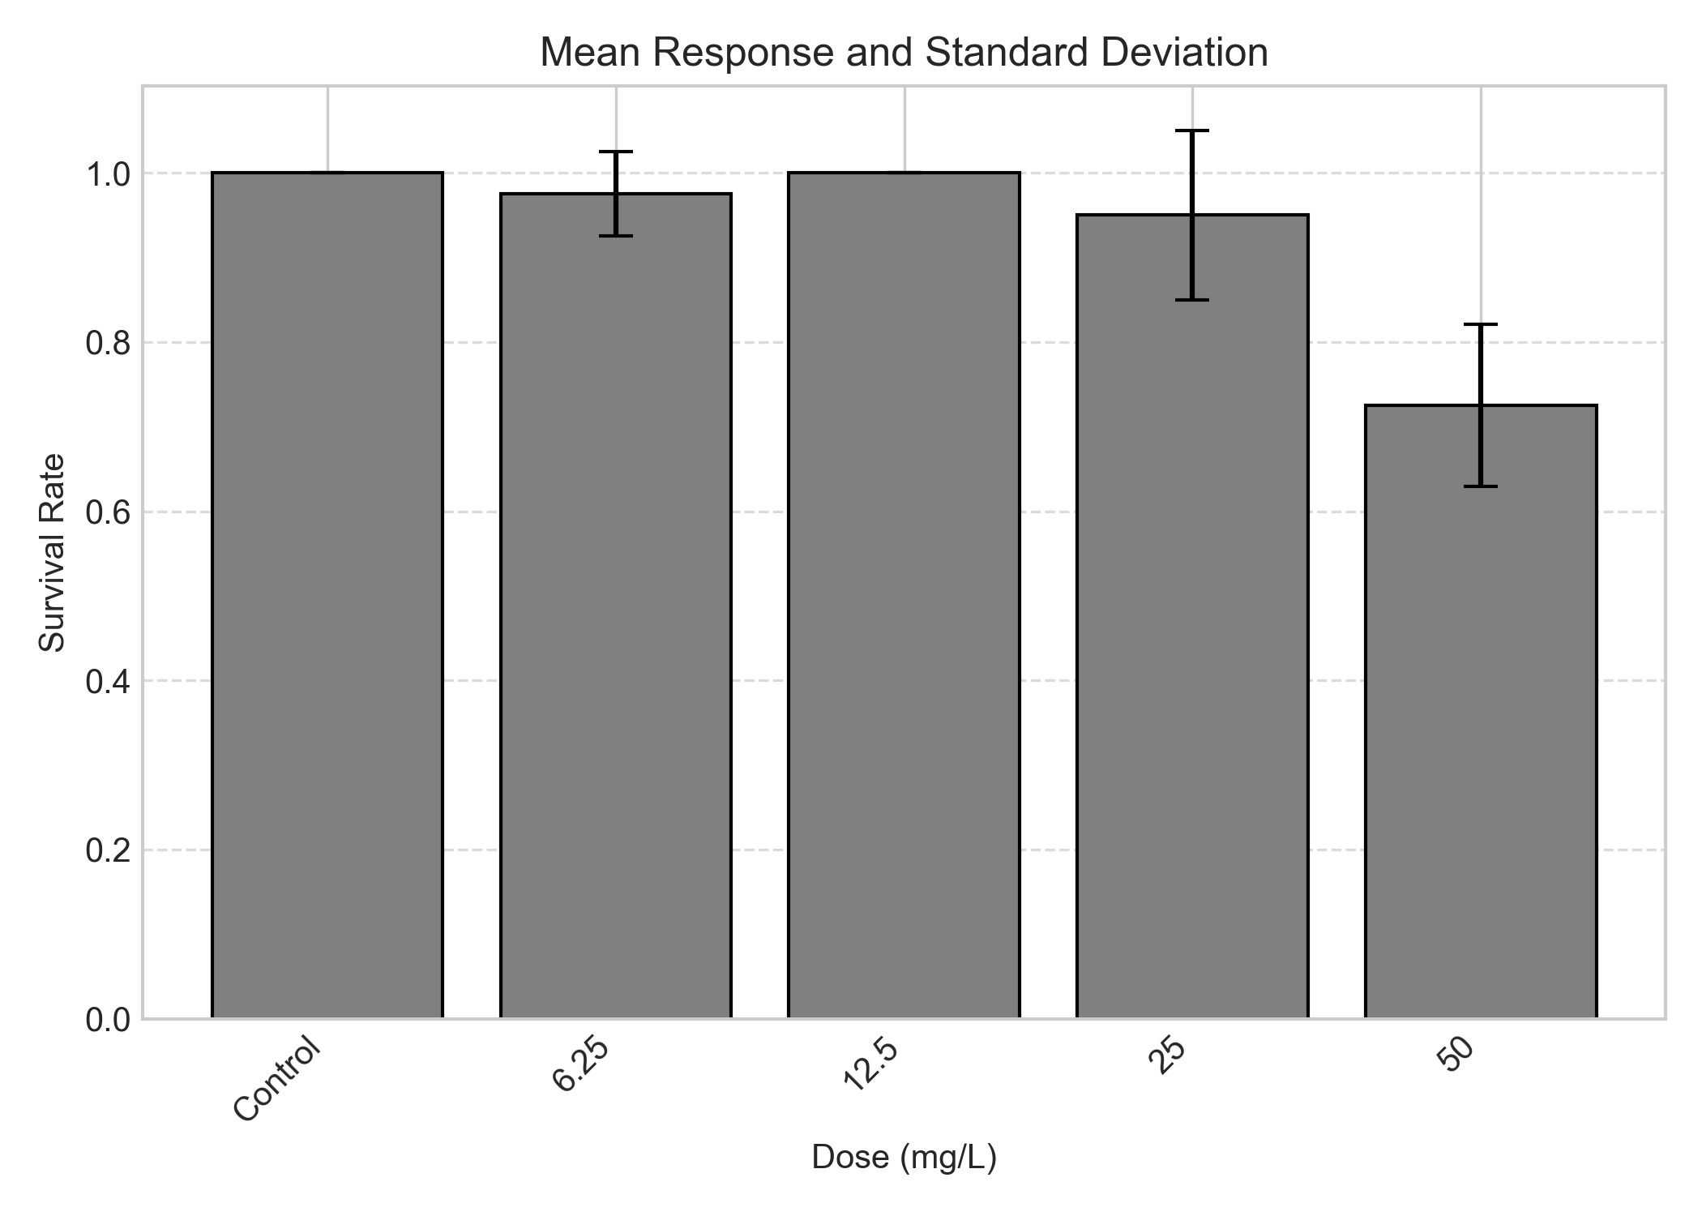
Figure 1. Dose-response trend for Survival Rate. Bars represent the mean and Standard Deviation (SD).

 | Analyst: | Toxgenie

