ToxGenie Algae & Cyanobacteria, Growth Inhibition Endpoints Analysis Report

Report Date: 2026-06-25 08:17:55

Test Type: | Definitive Test

Study No.: | Test-0123 | Test Material: | Test Material
Test Species: | Pseudokirchneriella subcapita | Exposure Time: | 72 hours

Table 1. Biomass (cells/mL) of Pseudokirchneriella subcapita during the 72 hours exposure

(Unit: mg/L)

Dose | Replicate No. | 0-hour | 24-hours | 48-hours | 72-hours
Dose | Replicate No. | 0-hour | 24-hours | 48-hours | 72-hours
Control | 1 | 5000 | 27800 | 162000 | 526000
Control | 2 | 5000 | 27800 | 164000 | 551000
Control | 3 | 5000 | 29600 | 198000 | 581000
Control | 4 | 5000 | 27400 | 150000 | 536000
Control | 5 | 5000 | 27900 | 154000 | 528000
Control | 6 | 5000 | 30800 | 181000 | 584000
 | Mean | 5000 | 28550 | 168167 | 551000
 | SD | 0 | 1344 | 18115 | 25954
1 | 1 | 5000 | 30700 | 187000 | 594000
1 | 2 | 5000 | 28600 | 151000 | 621000
1 | 3 | 5000 | 28600 | 179000 | 566000
 | Mean | 5000 | 29300 | 172333 | 593667
 | SD | 0 | 1212 | 18903 | 27502
2.2 | 1 | 5000 | 29600 | 161000 | 532000
2.2 | 2 | 5000 | 28400 | 154000 | 506000
2.2 | 3 | 5000 | 28500 | 152000 | 511000
 | Mean | 5000 | 28833 | 155667 | 516333
 | SD | 0 | 666 | 4726 | 13796
4.8 | 1 | 5000 | 27300 | 131000 | 434000
4.8 | 2 | 5000 | 27800 | 145000 | 463000
4.8 | 3 | 5000 | 25300 | 131000 | 422000
 | Mean | 5000 | 26800 | 135667 | 439667
 | SD | 0 | 1323 | 8083 | 21079
10 | 1 | 5000 | 22400 | 99800 | 330000
10 | 2 | 5000 | 21600 | 96800 | 339000
10 | 3 | 5000 | 21000 | 86500 | 350000
 | Mean | 5000 | 21667 | 94367 | 339667
 | SD | 0 | 702 | 6976 | 10017
23 | 1 | 5000 | 13400 | 27400 | 49200
23 | 2 | 5000 | 14200 | 29900 | 52600
23 | 3 | 5000 | 11300 | 27800 | 51800
 | Mean | 5000 | 12967 | 28367 | 51200
 | SD | 0 | 1498 | 1343 | 1778
50 | 1 | 5000 | 7440 | 6680 | 6930
50 | 2 | 5000 | 5990 | 6240 | 6530
50 | 3 | 5000 | 7520 | 6740 | 6320
 | Mean | 5000 | 6983 | 6553 | 6593
 | SD | 0 | 861 | 273 | 310

0-hour: Nominal initial biomass, SD: Standard Deviation

Table 2. Increase of biomass in the control cultures within the 72 hours test period

Replicate No. | 0-day | 1-day | 2-day | 3-day | 0-3 day
1 | 5000 | 27800 | 162000 | 526000 | 105.2
2 | 5000 | 27800 | 164000 | 551000 | 110.2
3 | 5000 | 29600 | 198000 | 581000 | 116.2
4 | 5000 | 27400 | 150000 | 536000 | 107.2
5 | 5000 | 27900 | 154000 | 528000 | 105.6
6 | 5000 | 30800 | 181000 | 584000 | 116.8
Mean |  |  |  |  | 110.2

Validity Check: The biomass in control cultures increased by a factor of 110.2. This exceeds the OECD 201 validity criterion (factor >= 16), indicating that the test conditions allowed for sufficient unrestricted exponential growth.

Table 3. Mean CV(%) for section-by-section specific growth rate in the control cultures

Replicate No. | 1-2 day | 2-3 day | Mean | SD | CV(%)
1 | 1.7626 | 1.1777 | 1.4701 | 0.4136 | 28.1305
2 | 1.7748 | 1.2119 | 1.4933 | 0.3981 | 26.6565
3 | 1.9005 | 1.0765 | 1.4885 | 0.5827 | 39.1446
4 | 1.7001 | 1.2735 | 1.4868 | 0.3016 | 20.2884
5 | 1.7083 | 1.2321 | 1.4702 | 0.3367 | 22.9019
6 | 1.7710 | 1.1714 | 1.4712 | 0.4240 | 28.8178
Mean |  |  |  |  | 27.6566

SD: Standard Deviation
Validity Check: The mean coefficient of variation (CV) for section-by-section specific growth rates was 27.66%. This is within the OECD 201 limit (<= 35%), demonstrating that stable exponential growth was maintained throughout the test duration.

Table 4. CV(%) of average specific growth rates in replicate control cultures during the whole test period

Replicate No. | 0-3 day | 0-1 day | 1-2 day | 2-3 day
1 | 1.5520 | 1.7156 | 1.7626 | 1.1777
2 | 1.5674 | 1.7156 | 1.7748 | 1.2119
3 | 1.5851 | 1.7783 | 1.9005 | 1.0765
4 | 1.5582 | 1.7011 | 1.7001 | 1.2735
5 | 1.5532 | 1.7192 | 1.7083 | 1.2321
6 | 1.5868 | 1.8181 | 1.7710 | 1.1714
Mean | 1.5671 | 1.7413 | 1.7695 | 1.1905
SD | 0.0156 | 0.0462 | 0.0718 | 0.0672
CV(%) | 0.9943 | 2.6556 | 4.0592 | 5.6482

SD: Standard Deviation
Validity Check: The coefficient of variation (CV) for average specific growth rates in control replicates was 0.99%. This meets the OECD 201 criterion (<= 7% for Pseudokirchneriella subcapita), confirming acceptable experimental precision and reproducibility.

Table 5. Average Growth Inhibitions (%) of Pseudokirchneriella subcapita

Dose | Replicate No. | Average Growth Rate | Inhibition (%)
Control | 1 | 1.5520 | 0.0000
Control | 2 | 1.5674 | 0.0000
Control | 3 | 1.5851 | 0.0000
Control | 4 | 1.5582 | 0.0000
Control | 5 | 1.5532 | 0.0000
Control | 6 | 1.5868 | 0.0000
 | Mean | 1.5671 | 0.0000
 | SD | 0.0156 | 0.0000
1 | 1 | 1.5925 | -1.6178
1 | 2 | 1.6073 | -2.5633
1 | 3 | 1.5764 | -0.5908
 | Mean | 1.5920 | -1.5906
 | SD | 0.0155 | 0.9866
2.2 | 1 | 1.5557 | 0.7269
2.2 | 2 | 1.5390 | 1.7927
2.2 | 3 | 1.5423 | 1.5836
 | Mean | 1.5457 | 1.3678
 | SD | 0.0089 | 0.5647
4.8 | 1 | 1.4879 | 5.0576
4.8 | 2 | 1.5094 | 3.6817
4.8 | 3 | 1.4785 | 5.6540
 | Mean | 1.4919 | 4.7977
 | SD | 0.0158 | 1.0114
10 | 1 | 1.3966 | 10.8846
10 | 2 | 1.4055 | 10.3123
10 | 3 | 1.4162 | 9.6331
 | Mean | 1.4061 | 10.2767
 | SD | 0.0098 | 0.6265
23 | 1 | 0.7622 | 51.3663
23 | 2 | 0.7844 | 49.9450
23 | 3 | 0.7793 | 50.2710
 | Mean | 0.7753 | 50.5274
 | SD | 0.0117 | 0.7446
50 | 1 | 0.1088 | 93.0569
50 | 2 | 0.0890 | 94.3215
50 | 3 | 0.0781 | 95.0168
 | Mean | 0.0920 | 94.1317
 | SD | 0.0156 | 0.9936

SD: Standard Deviation

Table 6. Model Comparison result: Fitted Models to the Dose-Average Growth Inhibition (%)

Model Name | R2 | MSE | Res. SD | AIC | Norm. P
Exponential | 0.8836 | 121.78213 | 10.79000 | 231.36 | 0.000
Gompertz | 0.9838 | 16.98272 | 3.67918 | 184.08 | 0.000
Logistic | 0.9972 | 2.87897 | 1.61606 | 141.49 | 0.363
Log-Logistic | -0.0000 | 1046.15054 | 32.34425 | 282.98 | 0.000
Weibull | 0.9970 | 3.16549 | 1.74107 | 143.76 | 0.035
Linear | 0.9842 | 16.53847 | 4.06675 | 183.45 | 0.241
Logistic with Hormesis | 0.9803 | 20.63340 | 4.22856 | 188.75 | 0.078

Best Model: Logistic (AIC = 141.49, R2 = 0.9972)

MSE: Mean Squared Error, Res. SD: Residual Standard Deviation, AIC: Akaike Information Criterion
Norm. P (Normality Test P-value)): Shapiro-Wilk Test P-value (P > 0.05 indicates normal residuals)

Table 8. Point Estimates: Average Growth Inhibition (%)

(Unit: mg/L)

Level | Estimates | 95% Lower Confidence Limit | 95% Upper Confidence Limit
ErC10 | 11.2625 | 10.2818 | 12.2431
ErC20 | 15.2013 | 14.5102 | 15.8924
ErC25 | 16.6513 | 16.0498 | 17.2527
ErC30 | 17.9325 | 17.3968 | 18.4682
ErC40 | 20.2085 | 19.7425 | 20.6746
ErC50 | 22.3143 | 21.8412 | 22.7873
ErC60 | 24.4283 | 23.8814 | 24.9752
ErC70 | 26.7336 | 26.0521 | 27.4151
ErC75 | 28.0427 | 27.2660 | 28.8194
ErC80 | 29.5366 | 28.6346 | 30.4387
ErC90 | 33.6962 | 32.2884 | 35.1040

Note: Logistic Model R2 = 0.9972 (>= 0.9). Estimates based on non-linear regression model.

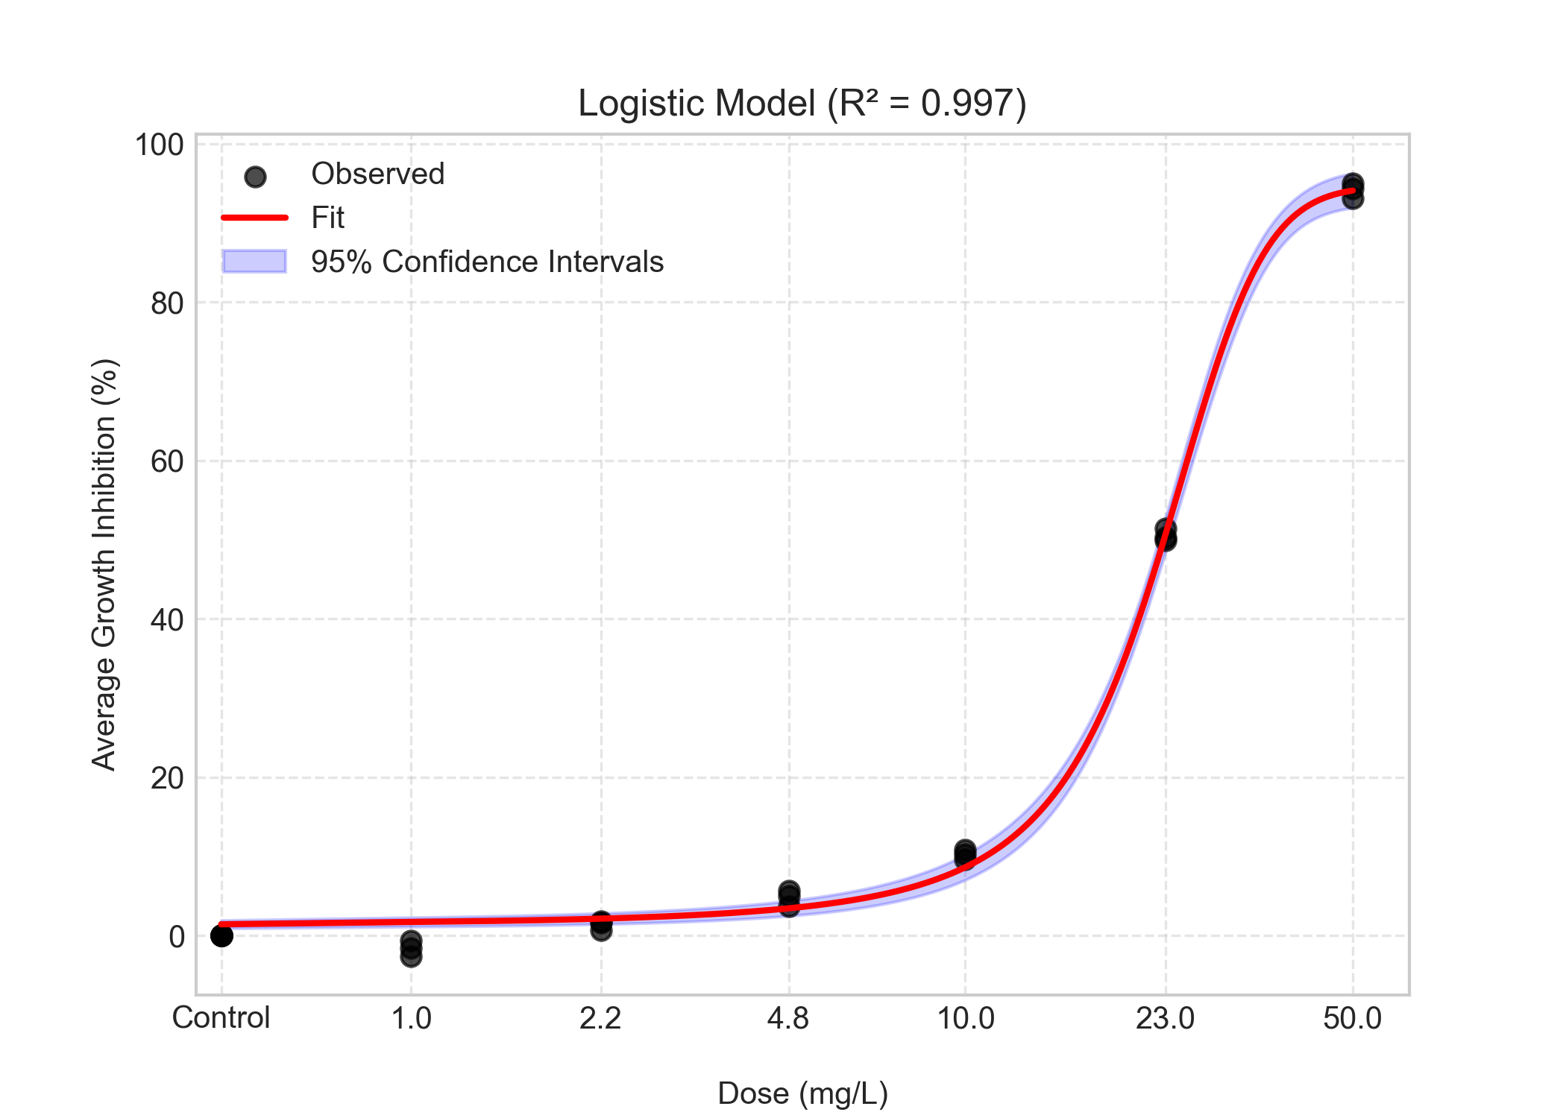
Figure 1. Dose-response curve for Average Growth Inhibition (%).

Table 9. Average Growth Inhibition (%): Quality Assurance (QA/QC) Summary

Parameter | Value / Status
Control Replicates (N) | 6
Control CV (%) | 0.00
Validity Flag | Pass

Methodology & Interpretation Guide

1. Statistical Parameters:
- Sample Size (N): 24 (Total number of observed data points).
- Degrees of Freedom (DoF): 21 (Calculated as N - Number of Model Parameters [3]).
- Higher DoF generally increases the statistical power.

2. Best Model Selection Criteria:
- Best Model selected based on AIC (Akaike Information Criterion).
- Lowest AIC indicates best balance between goodness-of-fit and complexity.
- Secondary criterion: R-squared (R2) >= 0.9.
- Consequently, the selected model 'Logistic' was chosen as it showed the best statistical fit

3. 95% Confidence Interval (CI) Calculation:
- Method used: Delta Method (Jacobian matrix).
- The 95% CI provides a range likely to contain the true parameter value.

Table 11. Yield Inhibitions (%) of Pseudokirchneriella subcapita

Dose | Replicate No. | Yield | Inhibition (%)
Control | 1 | 521000 | 0.0000
Control | 2 | 546000 | 0.0000
Control | 3 | 576000 | 0.0000
Control | 4 | 531000 | 0.0000
Control | 5 | 523000 | 0.0000
Control | 6 | 579000 | 0.0000
 | Mean | 546000 | 0.0000
 | SD | 25954 | 0.0000
1 | 1 | 589000 | -7.8755
1 | 2 | 616000 | -12.8205
1 | 3 | 561000 | -2.7473
 | Mean | 588667 | -7.8144
 | SD | 27502 | 5.0369
2.2 | 1 | 527000 | 3.4799
2.2 | 2 | 501000 | 8.2418
2.2 | 3 | 506000 | 7.3260
 | Mean | 511333 | 6.3492
 | SD | 13796 | 2.5268
4.8 | 1 | 429000 | 21.4286
4.8 | 2 | 458000 | 16.1172
4.8 | 3 | 417000 | 23.6264
 | Mean | 434667 | 20.3907
 | SD | 21079 | 3.8607
10 | 1 | 325000 | 40.4762
10 | 2 | 334000 | 38.8278
10 | 3 | 345000 | 36.8132
 | Mean | 334667 | 38.7057
 | SD | 10017 | 1.8345
23 | 1 | 44200 | 91.9048
23 | 2 | 47600 | 91.2821
23 | 3 | 46800 | 91.4286
 | Mean | 46200 | 91.5385
 | SD | 1778 | 0.3256
50 | 1 | 1930 | 99.6465
50 | 2 | 1530 | 99.7198
50 | 3 | 1320 | 99.7582
 | Mean | 1593 | 99.7082
 | SD | 310 | 0.0568

SD: Standard Deviation

Table 12. Model Comparison result: Fitted Models to the Dose-Yield Inhibition (%)

Model Name | R2 | MSE | Res. SD | AIC | Norm. P
Exponential | 0.6562 | 542.62068 | 23.12983 | 267.22 | 0.000
Gompertz | 0.9538 | 72.99425 | 8.20961 | 219.08 | 0.012
Logistic | 0.9777 | 35.18073 | 5.80793 | 201.56 | 0.032
Log-Logistic | -0.0000 | 1578.40010 | 39.72908 | 292.85 | 0.000
Weibull | 0.9756 | 38.59118 | 6.20138 | 203.78 | 0.441
Linear | 0.8421 | 249.29032 | 15.78893 | 248.56 | 0.005
Logistic with Hormesis | 0.9665 | 52.80522 | 6.73673 | 211.31 | 0.077

Best Model: Logistic (AIC = 201.56, R2 = 0.9777)

MSE: Mean Squared Error, Res. SD: Residual Standard Deviation, AIC: Akaike Information Criterion
Norm. P (Normality Test P-value)): Shapiro-Wilk Test P-value (P > 0.05 indicates normal residuals)

Table 14. Point Estimates: Yield Inhibition (%)

(Unit: mg/L)

Level | Estimates | 95% Lower Confidence Limit | 95% Upper Confidence Limit
EyC10 | 4.9584 | 3.5325 | 6.3842
EyC20 | 7.1704 | 6.1612 | 8.1796
EyC25 | 8.0125 | 7.0785 | 8.9466
EyC30 | 8.7654 | 7.8424 | 9.6884
EyC40 | 10.1184 | 9.0836 | 11.1532
EyC50 | 11.3840 | 10.1339 | 12.6341
EyC60 | 12.6651 | 11.1389 | 14.1914
EyC70 | 14.0731 | 12.2110 | 15.9353
EyC75 | 14.8778 | 12.8149 | 16.9408
EyC80 | 15.8015 | 13.5004 | 18.1026
EyC90 | 18.4146 | 15.3230 | 21.5062

Note: Logistic Model R2 = 0.9777 (>= 0.9). Estimates based on non-linear regression model. Unit: mg/L

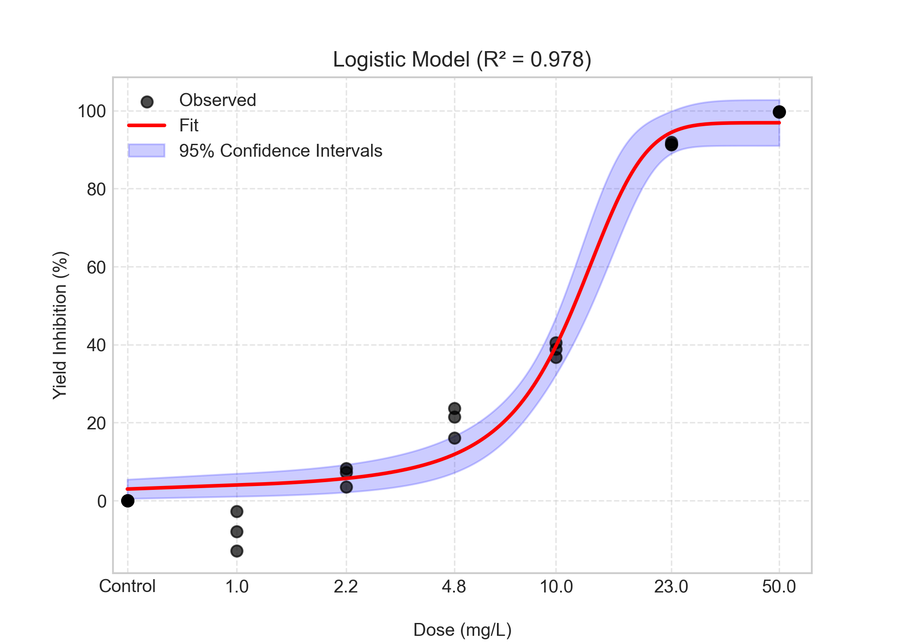
Figure 2. Dose-response curve for Yield (%).

Table 15. Yield Inhibition (%): Quality Assurance (QA/QC) Summary

Parameter | Value / Status
Control Replicates (N) | 6
Control CV (%) | 0.00
Validity Flag | Pass

Methodology & Interpretation Guide

1. Statistical Parameters:
- Sample Size (N): 24 (Total number of observed data points).
- Degrees of Freedom (DoF): 21 (Calculated as N - Number of Model Parameters [3]).
- Higher DoF generally increases the statistical power.

2. Best Model Selection Criteria:
- Best Model selected based on AIC (Akaike Information Criterion).
- Lowest AIC indicates best balance between goodness-of-fit and complexity.
- Secondary criterion: R-squared (R2) >= 0.9.
- Consequently, the selected model 'Logistic' was chosen as it showed the best statistical fit

3. 95% Confidence Interval (CI) Calculation:
- Method used: Delta Method (Jacobian matrix).
- The 95% CI provides a range likely to contain the true parameter value.

Table 17. Data Summary for Average Growth Rate
(Unit: mg/L)

Dose | 1 | 2 | 3 | 4 | 5 | 6 | Mean | SD
Control | 1.5519 | 1.5674 | 1.5851 | 1.5582 | 1.5532 | 1.5868 | 1.5671 | 0.0142
1 | 1.5925 | 1.6073 | 1.5764 | nan | nan | nan | 1.5921 | 0.0126
2.2 | 1.5557 | 1.5390 | 1.5423 | nan | nan | nan | 1.5457 | 0.0072
4.8 | 1.4879 | 1.5094 | 1.4785 | nan | nan | nan | 1.4919 | 0.0129
10 | 1.3965 | 1.4055 | 1.4162 | nan | nan | nan | 1.4061 | 0.0080
23 | 0.7621 | 0.7844 | 0.7793 | nan | nan | nan | 0.7753 | 0.0095
50 | 0.1088 | 0.0890 | 0.0781 | nan | nan | nan | 0.0920 | 0.0127

SD: Standard Deviation | (nan: not-a-number)

Table 18. Shapiro-Wilk's test for normality on the Average Growth Rate

Dose | Statistic | P-value | Result
Control | 0.85320 | 0.16703 | Normal Distribution
1 | 0.99944 | 0.95470 | Normal Distribution
2.2 | 0.89048 | 0.35582 | Normal Distribution
4.8 | 0.95056 | 0.57176 | Normal Distribution
10 | 0.99756 | 0.90566 | Normal Distribution
23 | 0.91102 | 0.42151 | Normal Distribution
50 | 0.97266 | 0.68278 | Normal Distribution

P>0.05 indicates Normal Distribution.
Final decision: The Average Growth Rate follows a normal distribution.

Table 19. Levene's test for homogeneity on the Average Growth Rate

Statistic | P-value | Result
0.33572 | 0.90857 | Equal Variances

P>0.05 indicates Equal Variances.
Final decision: The Average Growth Rate shows equal variances.

Statistical Analysis Procedure & Decision Tree

The statistical analysis for 'Average Growth Rate' was conducted based on the following decision steps:

1. Assumption Verification (Normality & Homogeneity):
- Since the raw data satisfied both the Shapiro-Wilk test (Normality)and Levene's test (Homogeneity of Variance), no data transformation was required.
- Consequently, the analysis proceeded directly to Parametric Tests.

2. Data Transformation Strategy:
- Not applicable (The raw data already satisfied statistical assumptions).

3. Final Selected Test Method:
- Because the data satisfied the required statistical assumptions (Normality and Homogeneity of Variance), the T-Test with Bonferroni Adjustment (Parametric) was selected as the post-hoc test.
- Prior to this post-hoc analysis, an Omnibus Test (One-Way ANOVA) was performed to confirm if any statistically significant differences exist among the dose groups (p < 0.05).
- The selected method is appropriate for comparing multiple treatment groups against a single control group to determine the NOEC/LOEC (No Observed Effect Concentration/Lowest Observed Effect Concentration) or NOAEL/LOAEL (No Observed Adverse Effect Level/Lowest Observed Adverse Effect Level).

Table 20. One-Way ANOVA on the Average Growth Rate

F-statistic | P-value | Result
5289.6988 | 0.0000 | Significant differences among doses

P<0.05 indicates a statistically significant difference among groups.

Table 21. Post Hoc Analytical Method: T-Test with Bonferroni Adjustment on the Average Growth Rate data.

Control | Dose | T-statistic | P-value | Adjusted P-value | Result
Control | 1 | -2.26797 | 0.05765 | 0.34590 | No significant difference from control
Control | 2.2 | 2.16602 | 0.06701 | 0.40206 | No significant difference from control
Control | 4.8 | 6.79026 | 0.00026 | 0.00153 | Significant difference from control
Control | 10 | 16.06565 | 0.00000 | 0.00001 | Significant difference from control
Control | 23 | 76.84990 | 0.00000 | 0.00000 | Significant difference from control
Control | 50 | 133.90980 | 0.00000 | 0.00000 | Significant difference from control

P<0.05 indicates a statistically significant difference from the control.
Table 22. Average Growth Rate: NOEC and LOEC
(Unit: mg/L)

NOEC | 2.2
LOEC | 4.8

* NOEC: No Observed Effect Concentration
* LOEC: Lowest Observed Effect Concentration
Note: NOEC/LOEC are typically used for Effects on Biotic Systems where exposure is expressed as concentration (e.g., mg/L).
Note: In accordance with OECD TG 201, a statistically significant increase in growth at low concentrations (hormesis) is not considered an adverse effect and is therefore excluded from the LOEC determination.

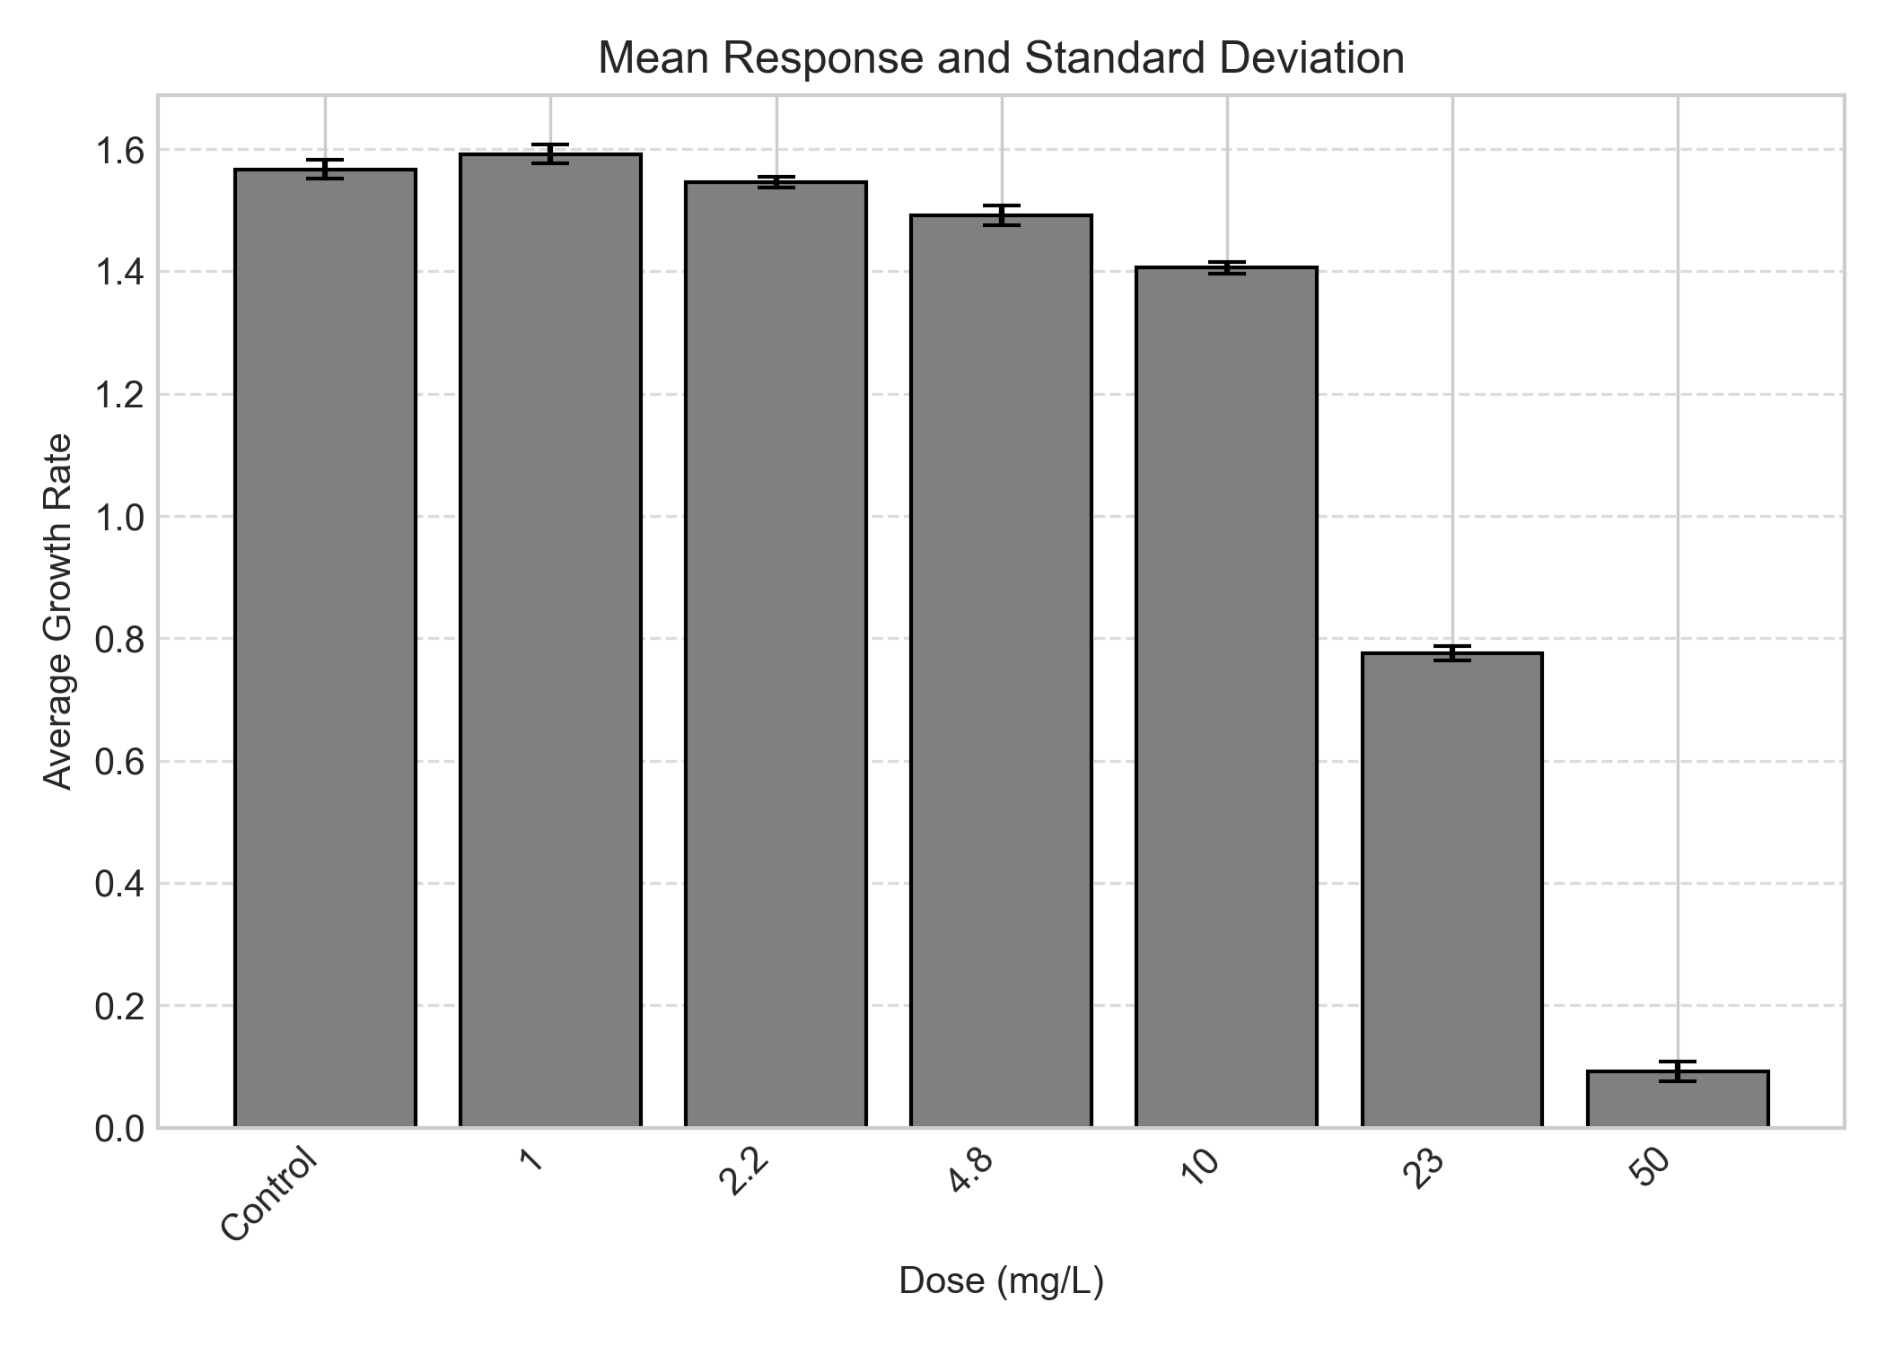
Figure 3. Dose-response plot for Average Growth Rate.

Table 24. Data Summary for Yield
(Unit: mg/L)

Dose | 1 | 2 | 3 | 4 | 5 | 6 | Mean | SD
Control | 521000 | 546000 | 576000 | 531000 | 523000 | 579000 | 546000 | 23692
1 | 589000 | 616000 | 561000 | nan | nan | nan | 588667 | 22455
2.2 | 527000 | 501000 | 506000 | nan | nan | nan | 511333 | 11264
4.8 | 429000 | 458000 | 417000 | nan | nan | nan | 434667 | 17211
10 | 325000 | 334000 | 345000 | nan | nan | nan | 334667 | 8179
23 | 44200 | 47600 | 46800 | nan | nan | nan | 46200 | 1451
50 | 1930 | 1530 | 1320 | nan | nan | nan | 1593 | 253

SD: Standard Deviation | (nan: not-a-number)

Table 25. Shapiro-Wilk's test for normality on the Yield

Dose | Statistic | P-value | Result
Control | 0.84964 | 0.15636 | Normal Distribution
1 | 0.99989 | 0.97995 | Normal Distribution
2.2 | 0.88792 | 0.34801 | Normal Distribution
4.8 | 0.94580 | 0.55125 | Normal Distribution
10 | 0.99668 | 0.88986 | Normal Distribution
23 | 0.91456 | 0.43346 | Normal Distribution
50 | 0.96867 | 0.66018 | Normal Distribution

P>0.05 indicates Normal Distribution.
Final decision: The Yield follows a normal distribution.

Table 26. Levene's test for homogeneity on the Yield

Statistic | P-value | Result
1.83951 | 0.15084 | Equal Variances

P>0.05 indicates Equal Variances.
Final decision: The Yield shows equal variances.

Statistical Analysis Procedure & Decision Tree

The statistical analysis for 'Yield' was conducted based on the following decision steps:

1. Assumption Verification (Normality & Homogeneity):
- Since the raw data satisfied both the Shapiro-Wilk test (Normality)and Levene's test (Homogeneity of Variance), no data transformation was required.
- Consequently, the analysis proceeded directly to Parametric Tests.

2. Data Transformation Strategy:
- Not applicable (The raw data already satisfied statistical assumptions).

3. Final Selected Test Method:
- Because the data satisfied the required statistical assumptions (Normality and Homogeneity of Variance), the T-Test with Bonferroni Adjustment (Parametric) was selected as the post-hoc test.
- Prior to this post-hoc analysis, an Omnibus Test (One-Way ANOVA) was performed to confirm if any statistically significant differences exist among the dose groups (p < 0.05).
- The selected method is appropriate for comparing multiple treatment groups against a single control group to determine the NOEC/LOEC (No Observed Effect Concentration/Lowest Observed Effect Concentration) or NOAEL/LOAEL (No Observed Adverse Effect Level/Lowest Observed Adverse Effect Level).

Table 27. One-Way ANOVA on the Yield data.

F-statistic | P-value | Result
501.9909 | 0.0000 | Significant differences among doses
P<0.05 indicates a statistically significant difference among groups.

Table 28. Post Hoc Analytical Method: T-Test with Bonferroni Adjustment on the Yield data.

Control | Dose | T-statistic | P-value | Adjusted P-value | Result
Control | 1 | -2.28514 | 0.05621 | 0.33725 | No significant difference from control
Control | 2.2 | 2.11854 | 0.07188 | 0.43125 | No significant difference from control
Control | 4.8 | 6.38490 | 0.00037 | 0.00224 | Significant difference from control
Control | 10 | 13.23668 | 0.00000 | 0.00002 | Significant difference from control
Control | 23 | 32.19342 | 0.00000 | 0.00000 | Significant difference from control
Control | 50 | 35.09854 | 0.00000 | 0.00000 | Significant difference from control

P<0.05 indicates a statistically significant difference from the control.
Table 29. Yield: NOEC and LOEC
(Unit: mg/L)

NOEC | 2.2
LOEC | 4.8

* NOEC: No Observed Effect Concentration
* LOEC: Lowest Observed Effect Concentration
Note: NOEC/LOEC are typically used for Effects on Biotic Systems where exposure is expressed as concentration (e.g., mg/L).
Note: In accordance with OECD TG 201, a statistically significant increase in growth at low concentrations (hormesis) is not considered an adverse effect and is therefore excluded from the LOEC determination.

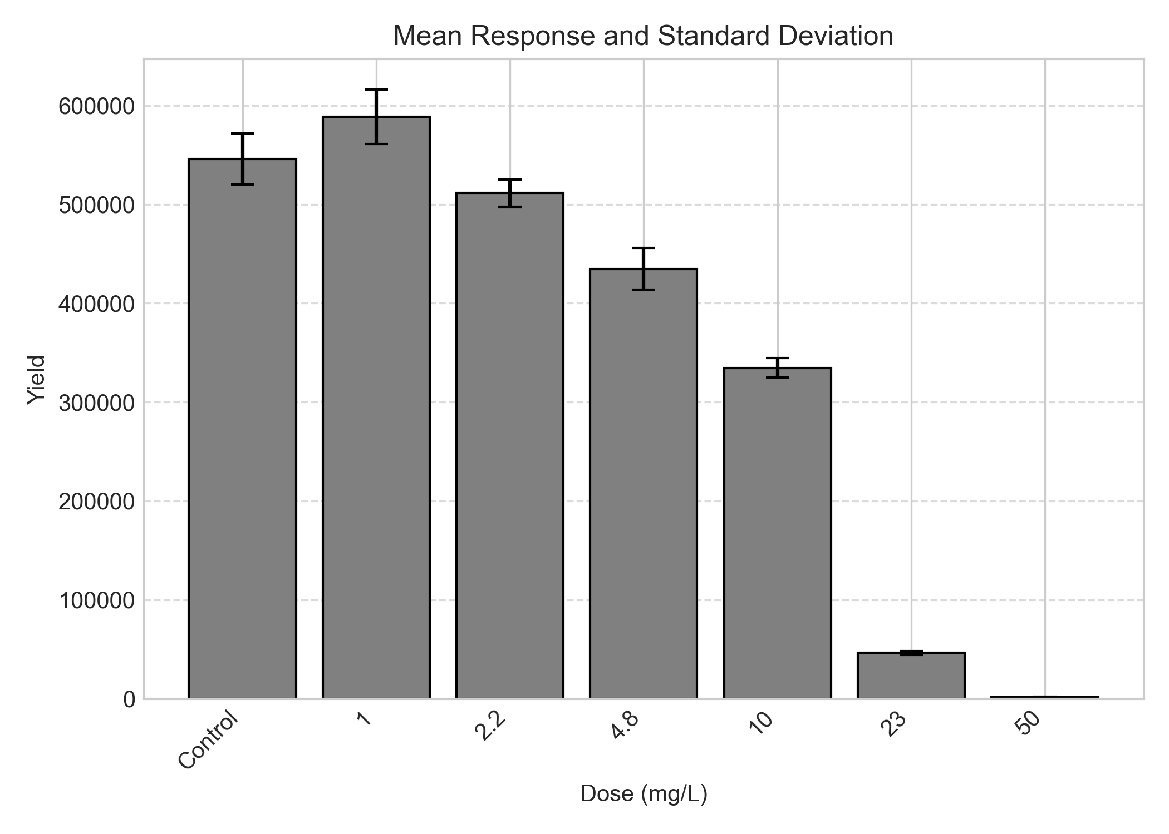
Figure 4. Dose-response plot for Yield.

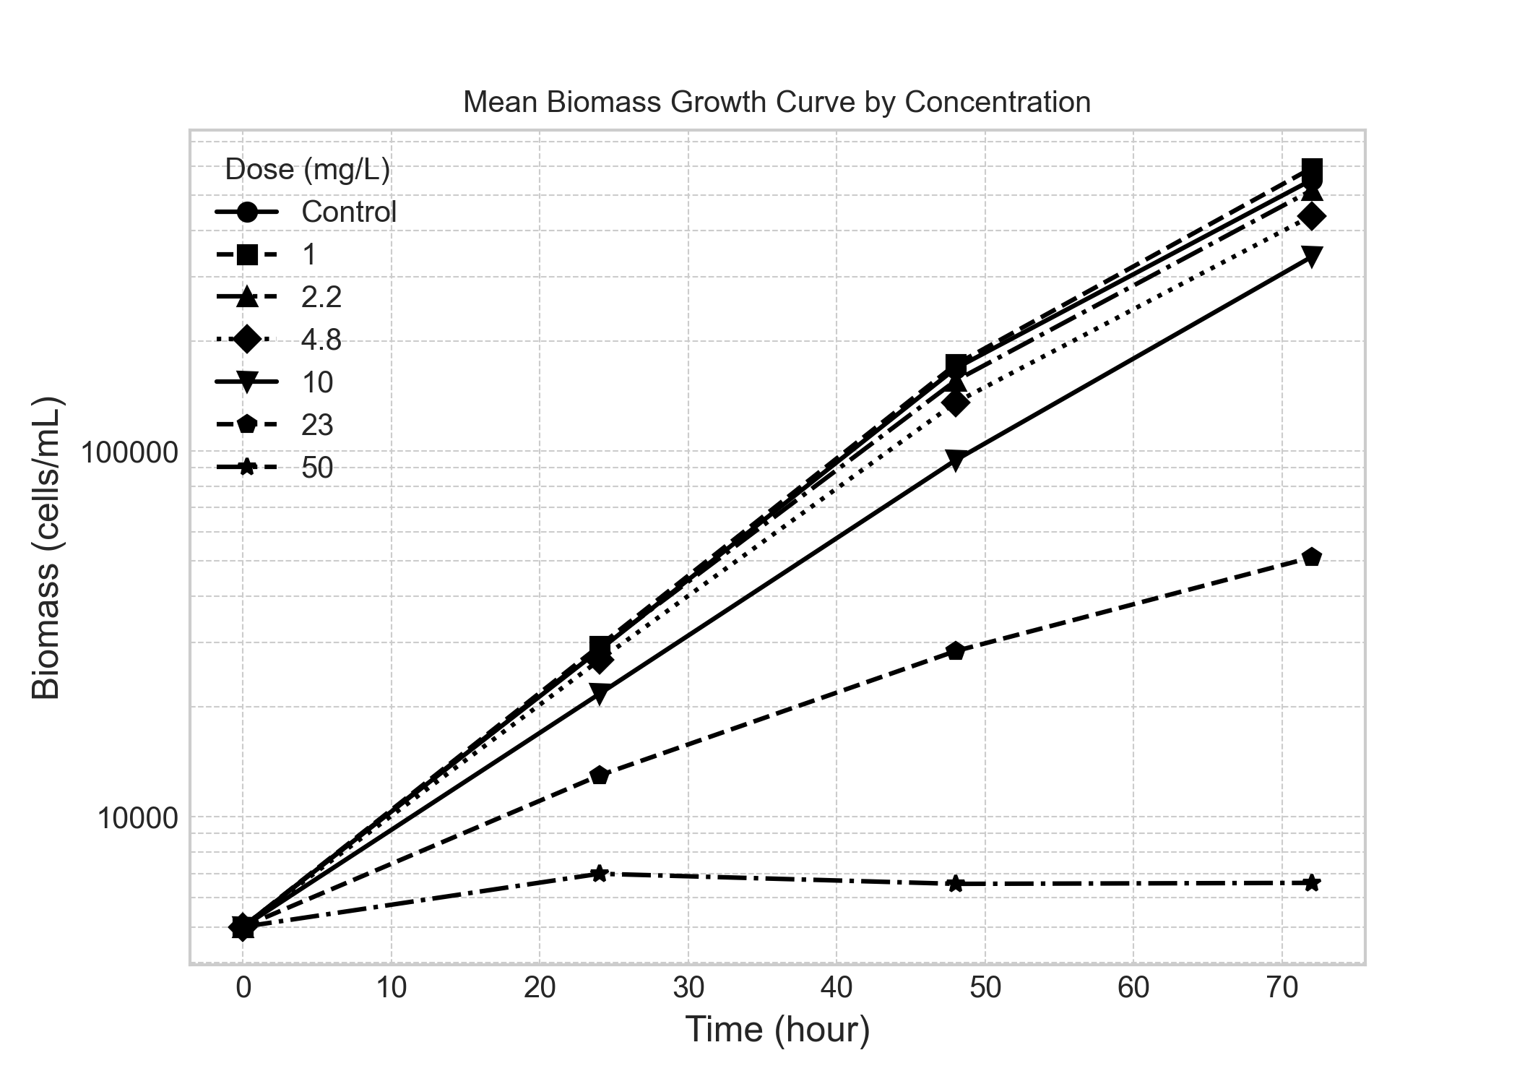
Figure 5. Mean biomass growth curve over time.

 | Analyst: | ToxGenie

