ToxGenie Point Estimation Report

Report Date: 2026-06-23 10:12:24

Study Title: | Zebrafish (Danio rerio) Acute Toxicity Test

Analysis Method: | Spearman-Karber Method (48-hour)

Study No.: | Sample-123 | Test Material: | Test Chemical
Test Species: | Zebrafish (Danio rerio) | Test Medium: | Natural Spring Water

Table 1. Data Summary for Spearman-Karber Method
(Unit: mg/L)

Dose | log10 Dose | No. Exposed | No. Responding | Proportion
Control | Control | 20 | 0 | 0.0000
6 | 0.7782 | 20 | 0 | 0.0000
13 | 1.1139 | 20 | 0 | 0.0000
25 | 1.3979 | 20 | 0 | 0.0000
50 | 1.6990 | 20 | 2 | 0.1000
100 | 2.0000 | 20 | 20 | 1.0000

Table 2. Spearman-Karber Calculations on the test data
(Unit: mg/L)

Dose | Proportion | Smoothed RP | Smoothed ARP
Control | 0.0000 | 0.0000 | 0.0000
6.0 | 0.0000 | 0.0000 | 0.0000
13.0 | 0.0000 | 0.0000 | 0.0000
25.0 | 0.0000 | 0.0000 | 0.0000
50.0 | 0.1000 | 0.1000 | 0.1000
100.0 | 1.0000 | 1.0000 | 1.0000

(Smoothed RP: Smoothed Response Proportion, Smoothed ARP: Smoothed Adjusted Response Portion)

Table 3. Point Estimates

(Unit: mg/L)

Level | Estimates | 95% Lower Confidence Limit | 95% Upper Confidence Limit
LC50 | 65.97540 | 59.97157 | 72.58028

Confidence Limits calculated by Spearman-Karber method.

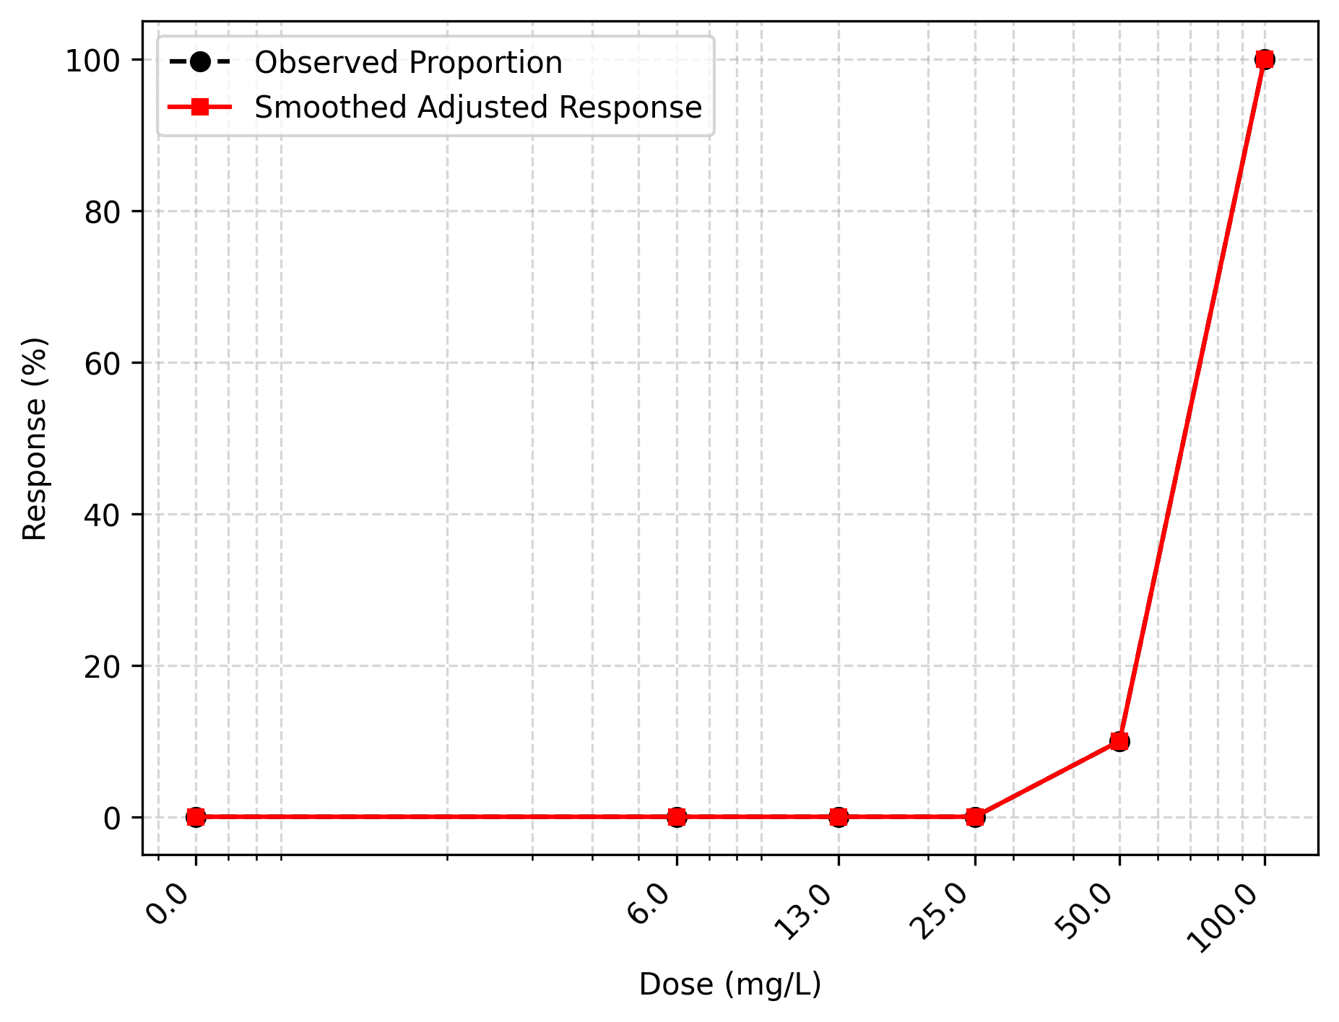
Figure 1. Dose-Response Curve for 48-hour.

 | Analyst: | ToxGenie

